**IFT 266 Introduction to Network Information Communication Technology (ICT)   
  
Lab 28**

**DHCPv6 Stateful Configuration via a router and via a server**

Co-authored by John Flaherty and Jessie Jones

**After you complete each step, put a ‘√’ or ‘x’ in the completed box**

**Part A:**  Configure a router to provide DHCPv6 stateful configuration for any attached clients.

1. Set up the following simple topology in packet tracer.

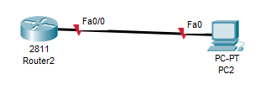



1. Enable unicast routing on the router

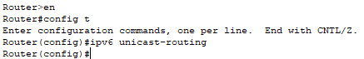



1. In order to create a DHCP pool that clients can pull addresses from, you will need to create a pool, add the prefix, DNS server, and domain name



Note: ASU can be replaced with a pool name of your choice.   
The prefix delegation name is also your choice.   
The DNS and domain name will change depending on the network, of course.



1. We then add an IPv6 prefix to the LOCAL pool created before:





1. To activate, we change the interface on the router;

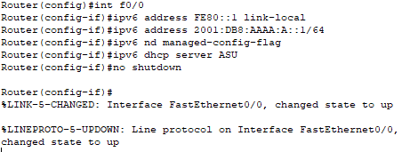

Note: The command “nd managed-config-flag” tells clients attached to the router to pull IPv6 addresses from its pool.

The command “dhcp server ASU” assigns the DHCP prefix pool to this interface.



1. Finally, access the PC IP Configuration under the Desktop tab, and select DHCP under IPv6 Configuration. If you performed all the previous steps, the DHCPv6 request should be successful.

**TIP**

You’re your current version of packet tracer may not have the DHCP configure option on the PCs.   
Download Packet Tracer Version 6.1.1 from below this lab and it will be there on the PCs.

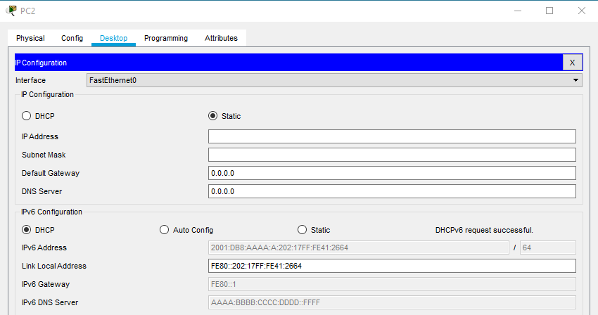

**Part B:**  Configure a server to provide DHCPv6 stateful configuration for any attached clients.

1. Set up the following simple topology in packet tracer.

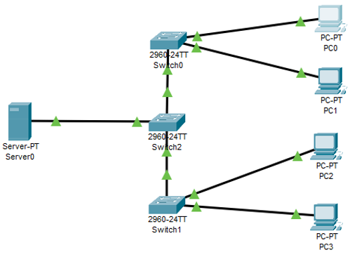

1. Access **Server0** > click the **Service** Tab > then click on the **DHCPv6 Box**.

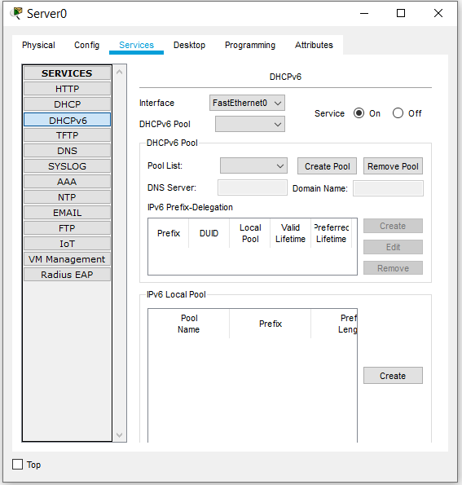

Make sure turn the service to **ON** (as in the image above)



1. Next,under the DHCPv6 Pool section click **Create Pool**.

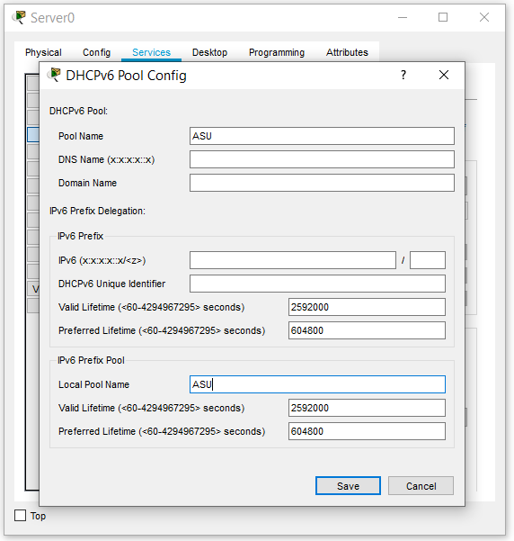

Fill in the infermation below:

Pool Name : ASU

Local Pool Name: ASU

Then **Save**.



1. Under the IPv6 Local Pool section click **Create**.

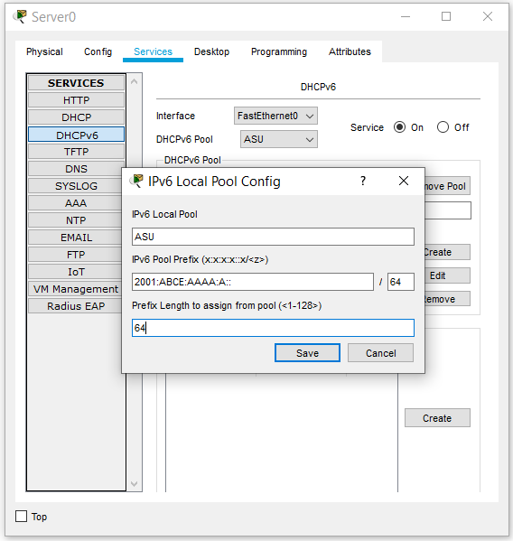

Fill in the infermation below (as shown in the above image)

IPv6 Local Pool: ASU

IPv6 Pool Prefix: 2001:ABCD:AAAA:A::/64

Prefix Length: 64

Then **Save.**

1. Go to **PC0** > **Desktop** > **IP Configuration**.

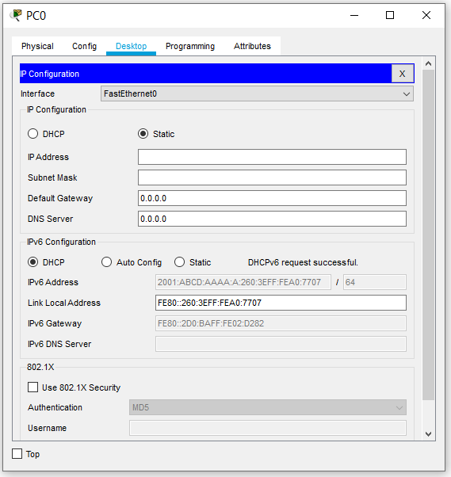

Under IPv6 configeration section, click the **DHCP** radio button

Repeat for all PCs.

Note: All PCs should receive a IPv6 Global Address from the server. If not, troubleshoot.

1. If everything was done correctly, all the PCs should be able to ping each other.  
     
   Attached a screenshot of a successful ping from PC0 → PC3 below.